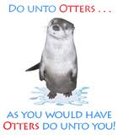
During Ms. McHale’s counseling lesson today, we discussed respecting others and their differences. We read a fantastic book called Do Unto Otters by Laurie Keller and discussed ways we show our good manners at school, home, and in our community. Below is an example of how your child shows respect to others.
Here is how I do unto ‘otters’…

